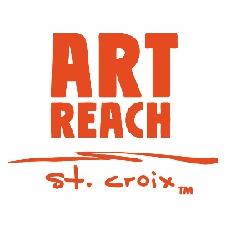
Art of the Stamp
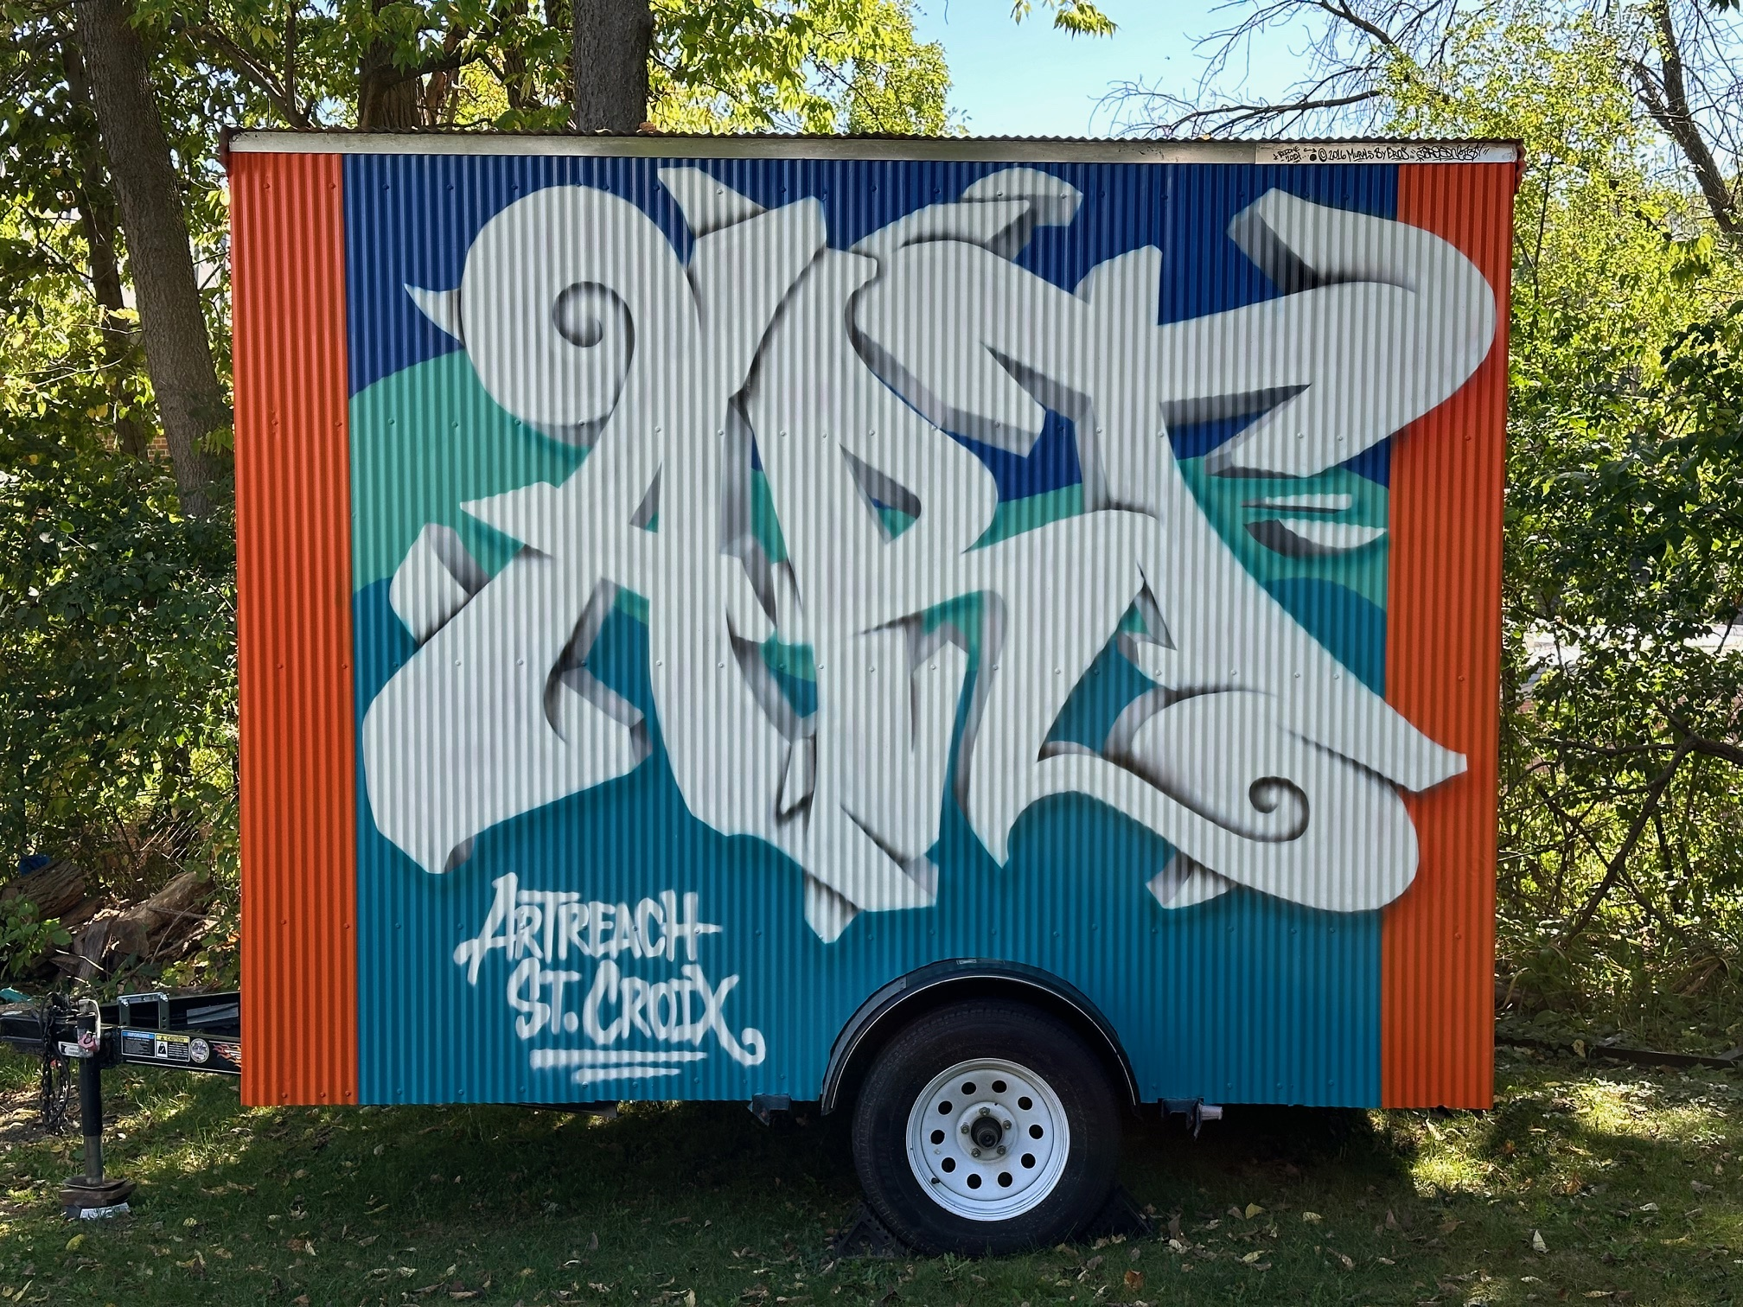
The Mobile Art Gallery was developed by ArtReach St. Croix to invite the community to have unexpected art experiences outside of a typical gallery.
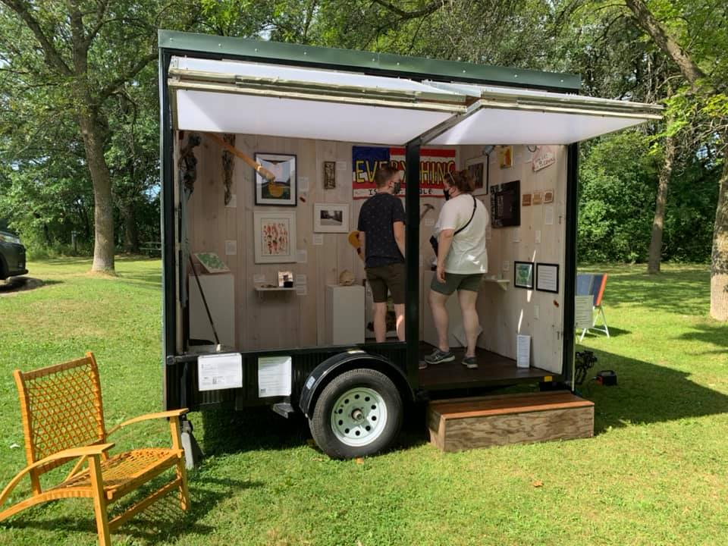Mending, the 2020 Mobile Art Gallery exhibition, was on display at Afton State Park (above), along the Brown’s Creek State Trail in Stillwater and outside the Walker Art Center, among other places.

Call for Artists
ArtReach St. Croix is seeking artists to create or format artwork around the impactful history of stamps as a method of public art distribution. This exhibition will celebrate the 250th year of the United States Postal Service for a touring exhibition in ArtReach’s Mobile Art Gallery.
Throughout 250 years, the USPS has taken many different forms. During early 1700’s, American colonists fostered many underground networks of posts, used mostly to hide rebellion from the British. The USPS became essential in sparking political culture during early American history. Early wagons, trains, lone horseman, and sled dogs brought mail across the American landscape through all terrain and weather, prompting the iconic but unofficial motto, “Neither snow nor rain nor heat nor gloom of night stays these couriers from the swift completion of their appointed roots.”
All forms of creative work are encouraged. All media, subjects and styles are welcome including—but not limited to—painting, fibers, printmaking, sculpture, glass, pottery, jewelry, mixed media, photography or video. All applications will be reviewed by members of ArtReach’s Visual Arts Committee to ensure an appropriate mix of work for the exhibition with some consideration for space.
Artists living and/or working in the St. Croix Valley are especially encouraged to submit applications. Artists can submit one piece of work for consideration though not all may be selected for the exhibition. Artists are encouraged, but not required, to submit a brief statement about their work and how it reflects the exhibition theme.
Art of the Stamp is funded in part by the NEA Big Read, a program of the National Endowment for the Arts in partnership with Arts Midwest.
Where:
ArtReach’s Mobile Art Gallery, Traveling to parks and festivals throughout the St Croix Valley
Dates to know:
March 30: Art Submission Forms Due
April 15: Accepted Artists Notified
May 4: Artwork drop-off, 10am-3pm*
*If this date does not work for you, please contact the gallery to schedule a drop-off time.
May 14: Reception, 6-8pm
Exhibition on view through mid-August
How to submit art:
Please complete the online submission form found at artreachstcroix.org/artofthestamp/ or send the completed form via email (to amy@artreachstcroix.org) or drop it off at the gallery during normal gallery hours.

SUBMISSION FORM
Art of the Stamp
Artists interested in having their work included in ArtReach St. Croix’s exhibition—Art of the Stamp—should complete this submission form for up to two pieces of work and return it by Monday, March 30th. An online version of this form is available at artreachstcroix.org/artofthestamp/
ARTIST INFORMATION
Name___________________________________________________________________________________________
Address__________________________________________________________________________________________
City, State, Zip_____________________________________________________________________________________
Phone_______________________________ Email________________________________________________________
ARTIST INFORMATION
Name___________________________________________________________________________________________
Address__________________________________________________________________________________________
City, State, Zip_____________________________________________________________________________________
Phone_______________________________ Email________________________________________________________
Brief statement about this artwork
__________________________________________________________________________________________________
__________________________________________________________________________________________________
__________________________________________________________________________________________________
__________________________________________________________________________________________________
□ I have emailed a JPEG image of my work to amy@artreachstcroix.org or am including a thumbdrive with the image.
□ ArtReach St. Croix has my permission to use my image for promotion of Art of the Stamp including print, online and social media.
There is no application fee for this call. ArtReach St. Croix’s commission rate for all artworks sold is 35% but pieces do not need to be for sale.
Artist Signature__________________________________________ Date__________________________
Required for participation
Works Cited
Gallagher, Winifred. “A Brief History of the United States Postal Service.” Smithsonian Magazine, Oct. 2020, www.smithsonianmag.com/smithsonian-institution/brief-history-united-states-postal-service-180975627/.
“No Official Motto - U.S. Postal Facts.” Postal Facts - U.S. Postal Service, 8 Mar. 2021, facts.usps.com/no-official-motto/

